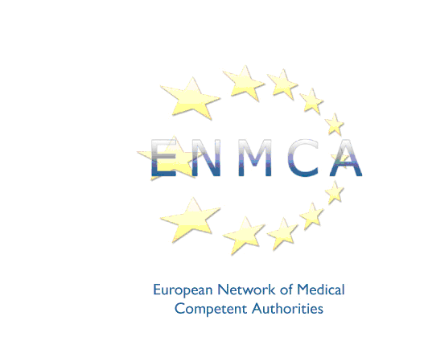


31st meeting of the
European Network of Medical Competent Authorities

Hosted by the Cyprus Medical Council

Radisson Blu Hotel, Atlantidon 2, 6058, Larnaca

Friday 7 June 2024

Please return this registration form by email to the ENMCA secretariat at contact@enmca.eu no later than Friday 10 May 2024

I would like to attend the meeting on Friday 7 June 2024

Name
Title
Competent Authority
Address
Telephone
Email

I will attend the dinner on Thursday 6 June at 19.30 at a traditional tavern:

YES / NO (please delete)

Please indicate in the box below whether you have any dietary or special requirements:

Attendance is by invitation only and registration is limited to two delegates per competent authority.

